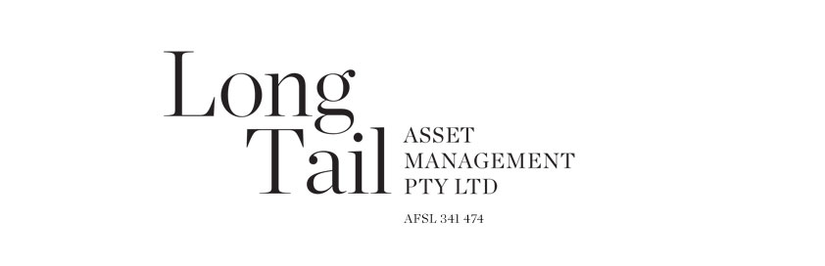
02/07/2013
The fund is the primary vehicle for the investment of our capital. Its current traits are:
- Highly stock specific investments that are concentrated in our few key ideas;
- The key ideas generally relate to companies that are not well known or popular investments;
- The fund currently has a significant USD and Euro exposure as a result of individual equity investments in these geographies;
- There is a meaningful mid cap / micro cap bias to the investments;
- Managed with consideration of tax for Australian investors; and
- An outcome of the direct short and Yen positions is that the fund has a meaningful short exposure to rising interest rates.
Returns |  |  |  |  | Fund
Since inception (annualised) |  |  |  |  | 11.3%
Since inception (cumulative) |  |  |  |  | 41.6%
Rolling 3 year (annualised) |  |  |  |  | 12.9%
Rolling 1 year |  |  |  |  | 36.1%
Standard deviation |  |  |  |  | 9.9%
Financial Year | 2010 | 2011 |  | 2012 |  | 2013
July |  | 1.14% |  | -1.95% |  | -3.06%
August |  | -0.33% |  | -0.32% |  | 0.45%
September |  | 0.60% |  | -2.18% |  | 1.89%
October |  | 2.12% |  | 0.83% |  | 1.30%
November |  | 0.47% |  | -1.22% |  | -2.46%
December |  | -0.24% |  | 0.27% |  | 6.93%
January |  | 0.31% |  | 0.84% |  | 9.92%
February |  | 1.78% |  | 0.02% |  | 2.69%
March |  | 1.06% |  | 5.59% |  | -0.44%
April | 0.04%* | -1.94% |  | 1.62% |  | 4.45%
May | -0.78% | 1.01% |  | -0.37% |  | 8.63%
June | -0.76% | -0.70% |  | -2.58% |  | 1.68%
Financial Year | -1.49% | 5.33% |  | 0.29% |  | 36.1%
Calendar Year |  | -3.10% |  | 10.12%
* Start date: 15/04/2010
The fund’s daily unit price and distribution details can be downloaded via this link.
 | Long (%) | Short (%) | Currency (%)
Australia | 5 | 9 | 53
United States* | 36 | 0 | 29
UK/Europe* | 20 | 0 | 18
Total | 61 | 9 | 100
Derivatives (annual cost) | 3
Notes: Data as at 02 July 2013. * Euro & USD approximate only.

 | Australia |  | United States |  | UK/Europe |  | Total
 | % | no/. | % | no/. | % | no/. | % | no/.
Tenet 1: US wagering |  |  | 17 | 2 |  |  | 17 | 2
Tenet 2: European airports |  |  |  |  | 17 | 3 | 17 | 3
Tenet 3: Not disclosed |  |  | 8 | 2 |  |  | 8 | 2
Other tenets | 5 | 3 | 12 | 4 | 3 | 2 | 19 | 9
Gross Long | 5 | 3 | 36 | 8 | 20 | 5 | 61 | 16
Gross short | 9 | 4 |  |  |  |  | 9 | 4
Gross invested position | 14 | 7 | 36 | 8 | 20 | 5 | 70 | 20
Derivatives (annual cost) |  |  |  |  |  |  | 3 | 4
Notes: Data as at 02 July 2013.

